Git and GitHub – Exercises
Exercises and homework assignments for “Software Technologies with AI” course at SoftUni AI.

Recommended Preparation
In this course and its exercise sessions, you will build multiple web pages that need to be run and tested locally. To make it easier to open HTML files in the browser, we recommend installing the Code Runner extension for Visual Studio Code. You can do so from [Extensions] Type "Code Runner" in the Search bar and install it.
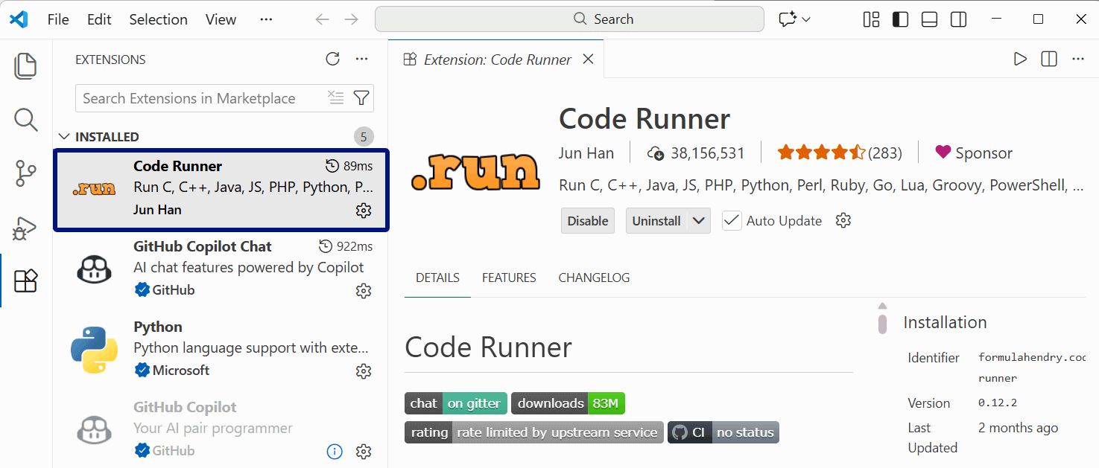
When it’s installed, go to [Settings]:
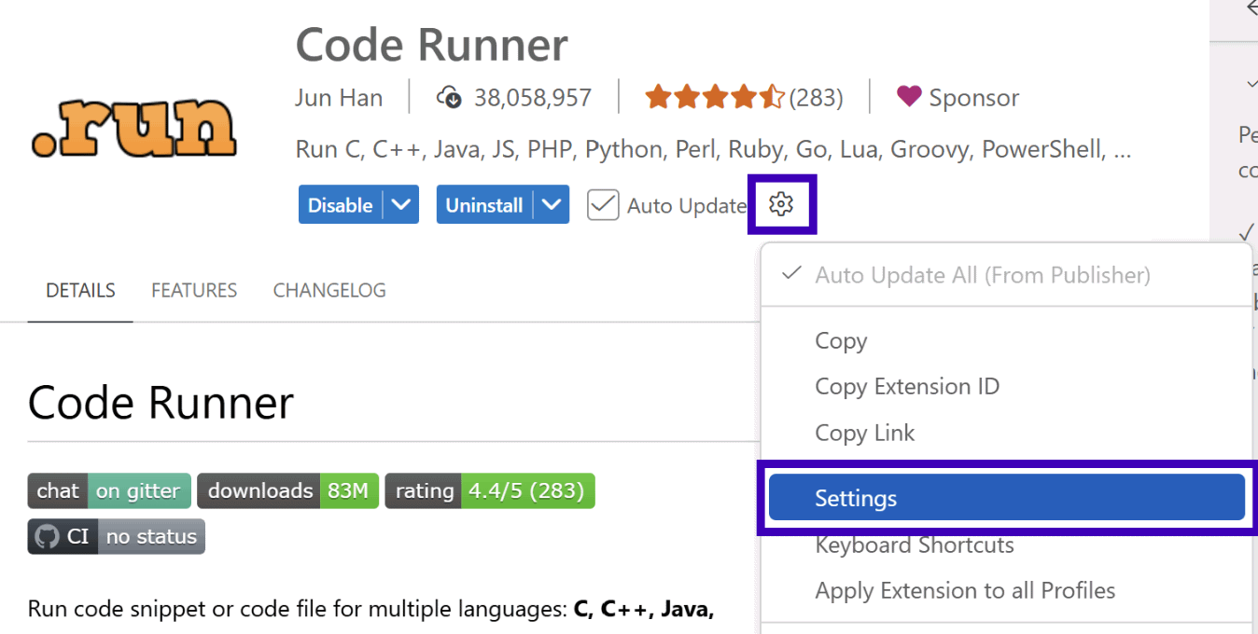
Scroll down until you see "Code-runner: Executor Map" and click [Edit in settings.json].
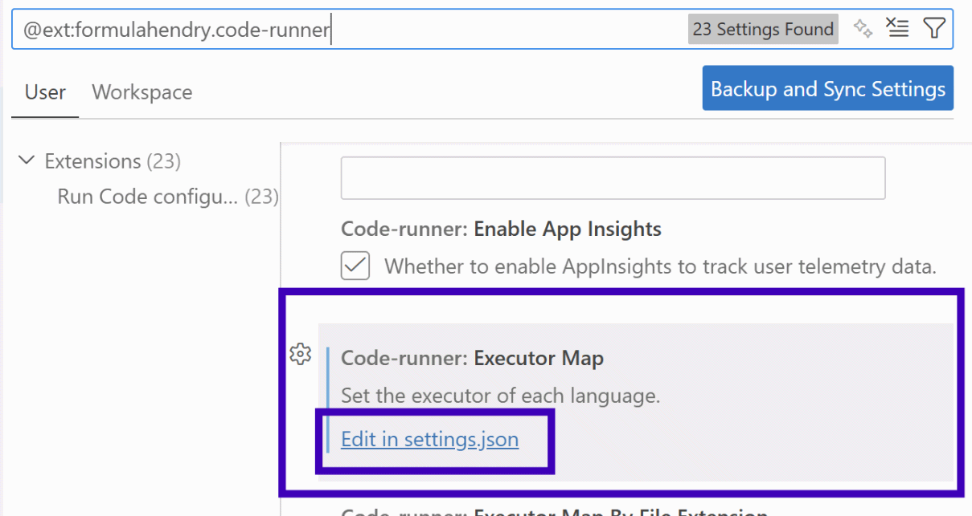
Add these three lines to the code as it is shown below (runners for HTML, CSS and JavaScript files). For the first and second lines write the browser you are using. In this case it is Chrome, but it may be different in your environment:
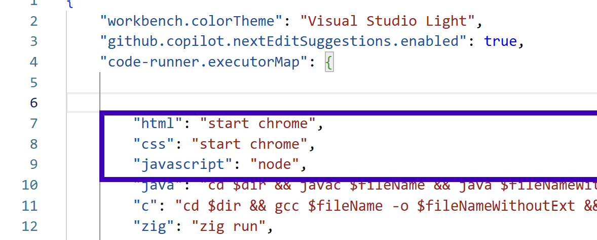
Save the file and close the tab. Now you will be able to run the currently open HTML file with a simple button click:
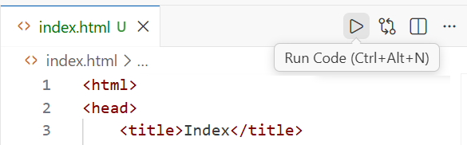

Company Website
Your task is to develop a business website for a company of your choice according to the following requirements:
- Structure the app into multiple HTML pages, with a single CSS.
- Keep your project in a GitHub repository.
- Implement continuous deployment from GitHub to Netlify.
- Build the site step-by step, with commit & push after each successful step.
You can follow the below described steps.

Create a New Project
Create an empty local folder that will hold your project and will be later tracked by Git:
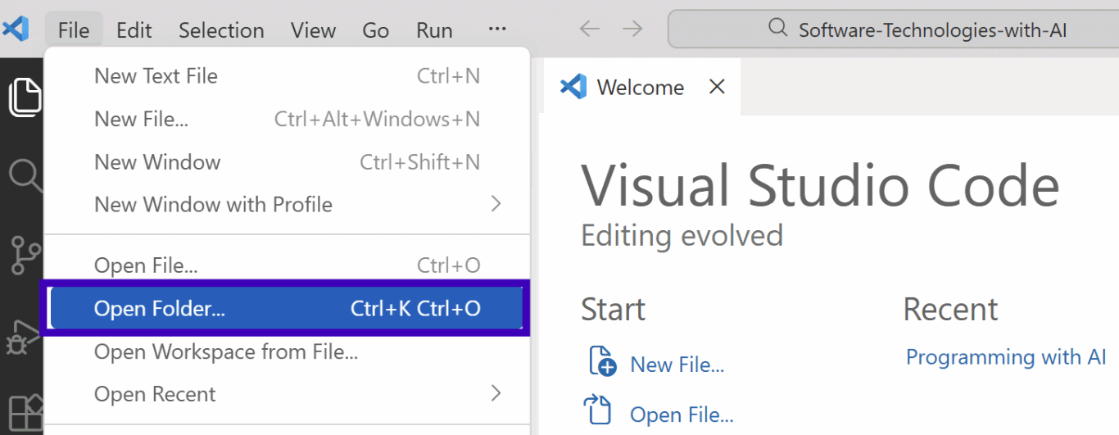
Open Visual Studio Code -> Open Folder, create your project folder and select it:
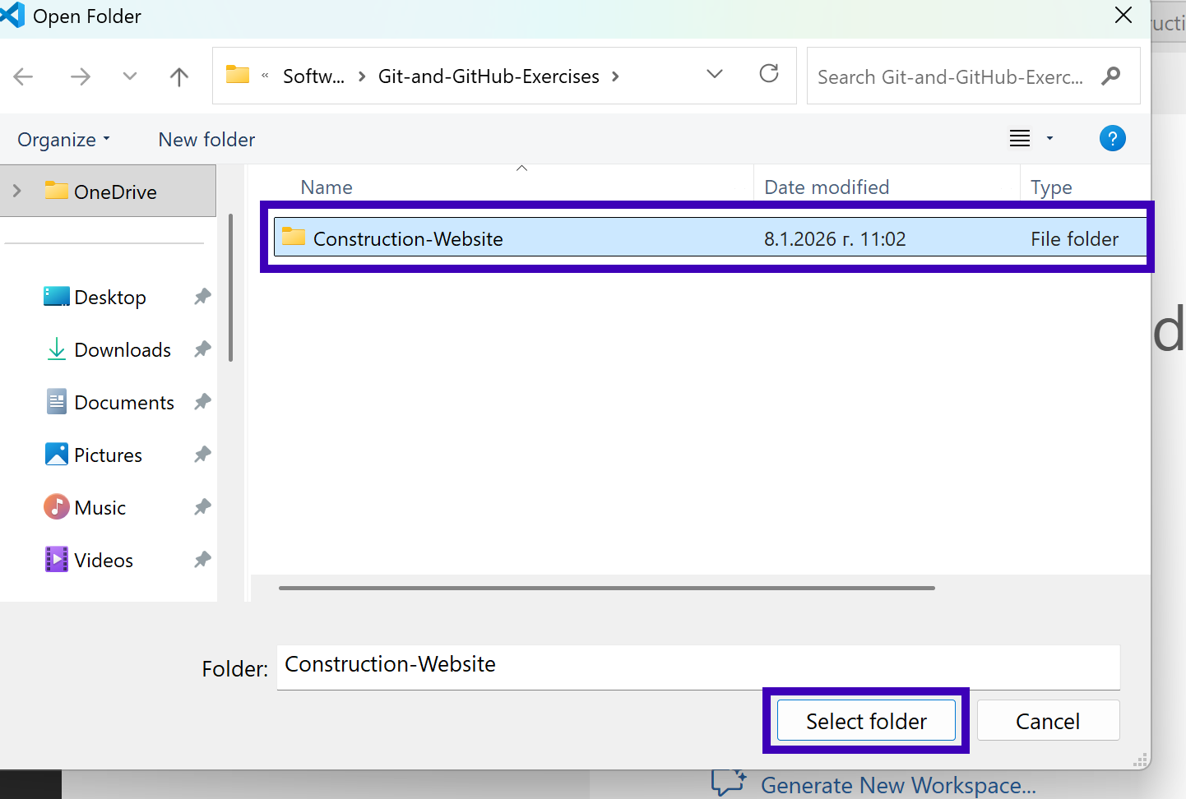
Create an empty index.html file inside the project folder. Make sure the file is saved in the correct project folder:
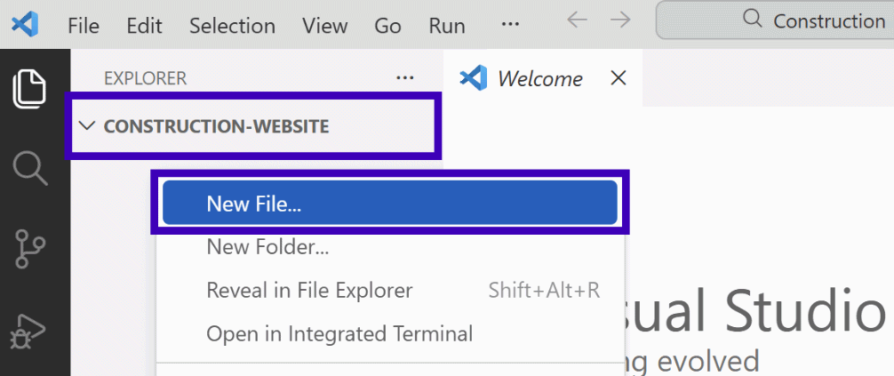

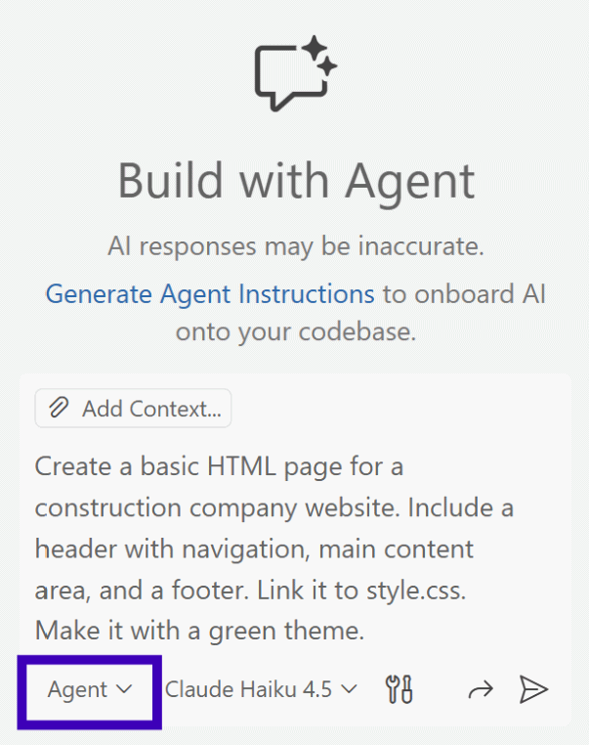
Define Site Structure
Define the site structure. Most websites should include:
- Header with navigation menus
- Main page content
- Footer with copyright and links
Ask GitHub Copilot to generate a webpage with these elements in it. Tell the chatbot to implement the site structure only, not the entire website at once. Before doing so, make sure that Copilot is in Agent mode and select a suitable AI model.
Write your prompt in the chat window. Providing more details usually leads to better initial results. You can always change and experiment additionally until you are satisfied with the results. Generated results may differ even when using the same prompt. This may happen, but it is not guaranteed. Keep this in mind and do not aim to replicate the lecture examples exactly:

Run and Test the Code
To run the page, right-click the index.html file and select [Run Code]:
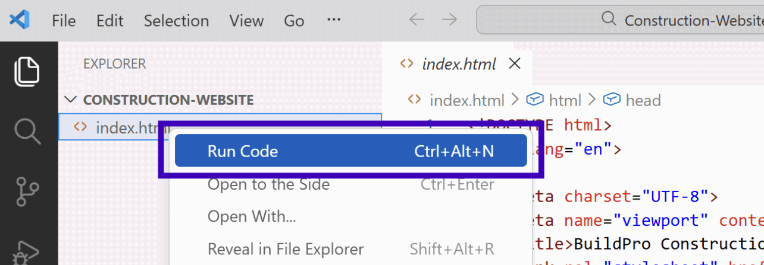
Copilot may build the HTML part of the website first and then ask you if you want to create the CSS file to make it visually appealing. It may also generate all required files at once. Review the chat output carefully. What you are aiming for is a webpage looking something like this (this is just a sample):


Publish the Project to GitHub
Once you are satisfied with the current result, commit and push the files to GitHub.
- Initialize the repository locally so Git can start tracking changes, then push them to GitHub.
Alternatively, you can use [Publish to GitHub] button directly from Visual Studio Code.
Go to the Source Control Icon and click [Publish to GitHub]:
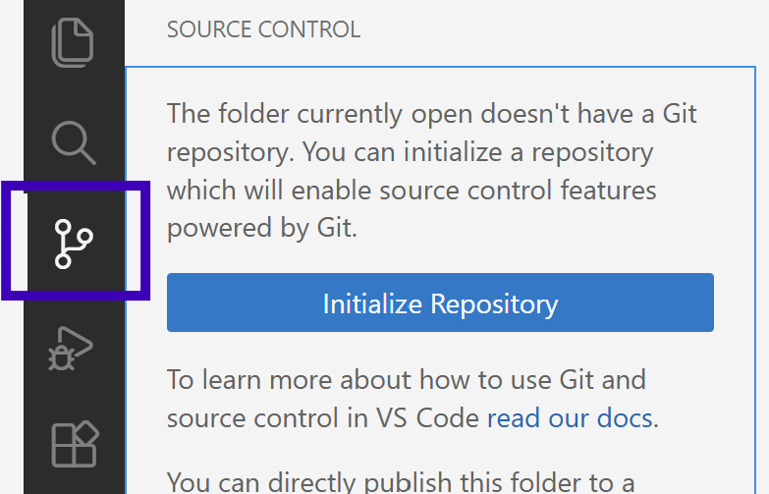
If you are not logged in to your GitHub profile, you may be asked to login.
Now you can click the [Publish Branch] button. Before you do so, make sure to write a message on what has been uploaded/updated:
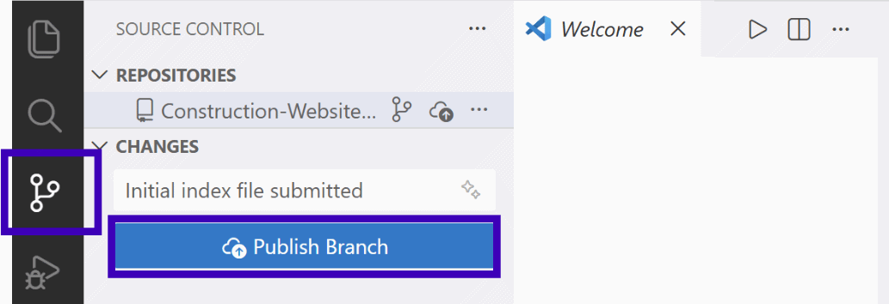

Commit and Push Changes
Now you can continue working on your project, e.g. by running more prompts with GitHub Copilot. At some moment later, when you have a stable version, you can commit the changes with the [Commit] button. Before committing, stage the changes and write a short commit message describing what has changed:
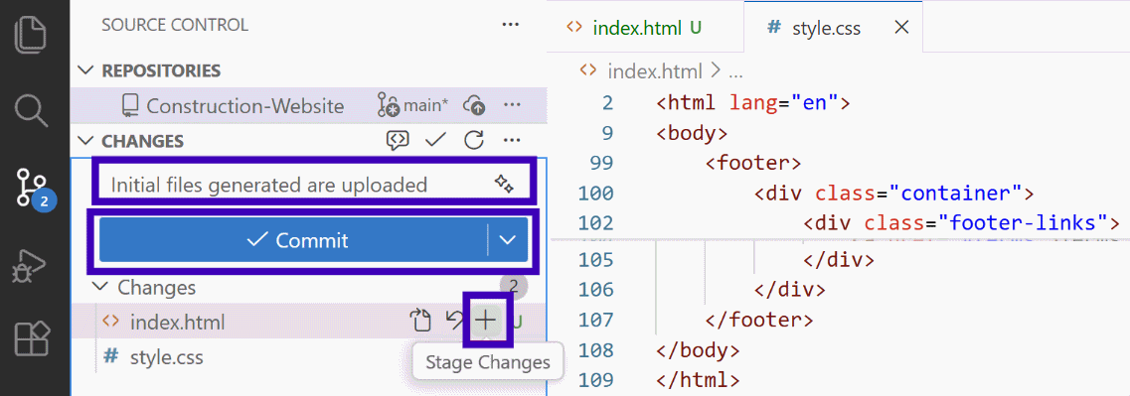
Finalize the action by pressing the [Sync Changes] button. By doing this you will push your commits to GitHub. In GitHub language Sync Changes = Push + Pull (when a new version is available at the server):
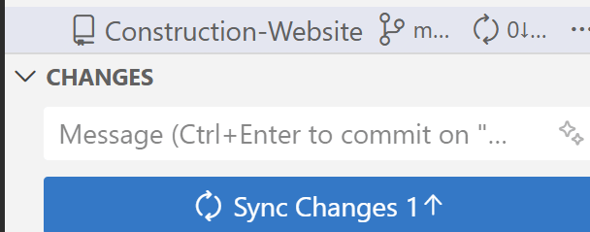
Now you should be able to see your project files in your GitHub.com profile online:
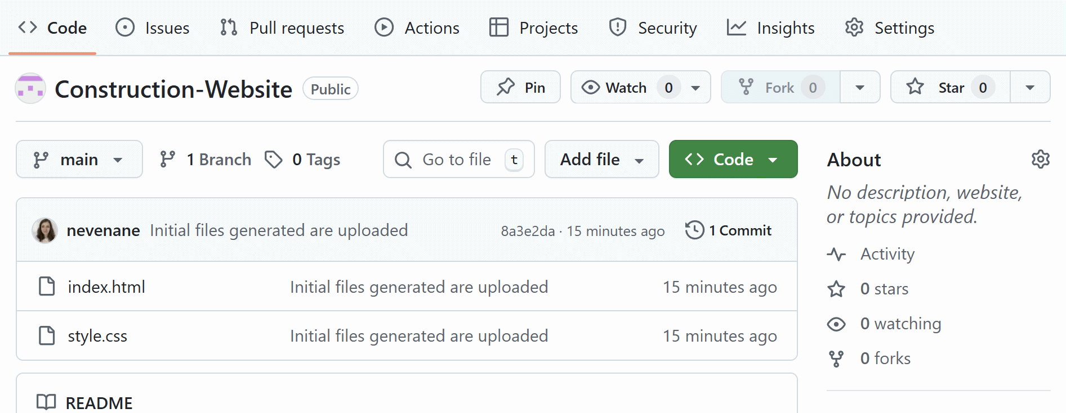
Explain the content of your GitHub repository in the README file on your repository for the project. This file serves as the main documentation for the project. You can create a README.md file from the browser:
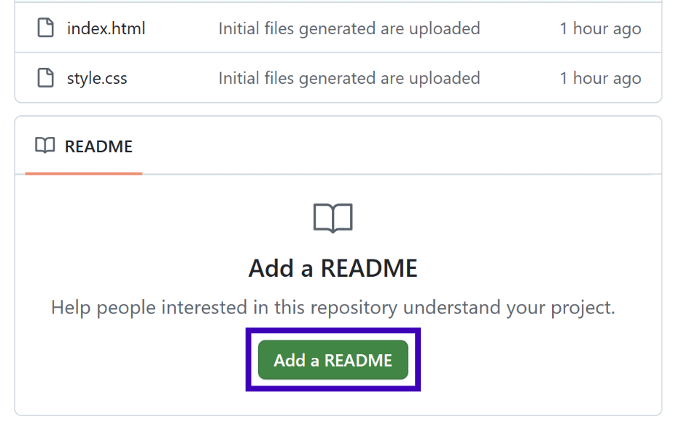
Alternatively, you can ask GitHub Copilot to generate the README.md documentation for you.
It should look like this, and you can update it whenever you need to through browser or through Visual Studio Code:
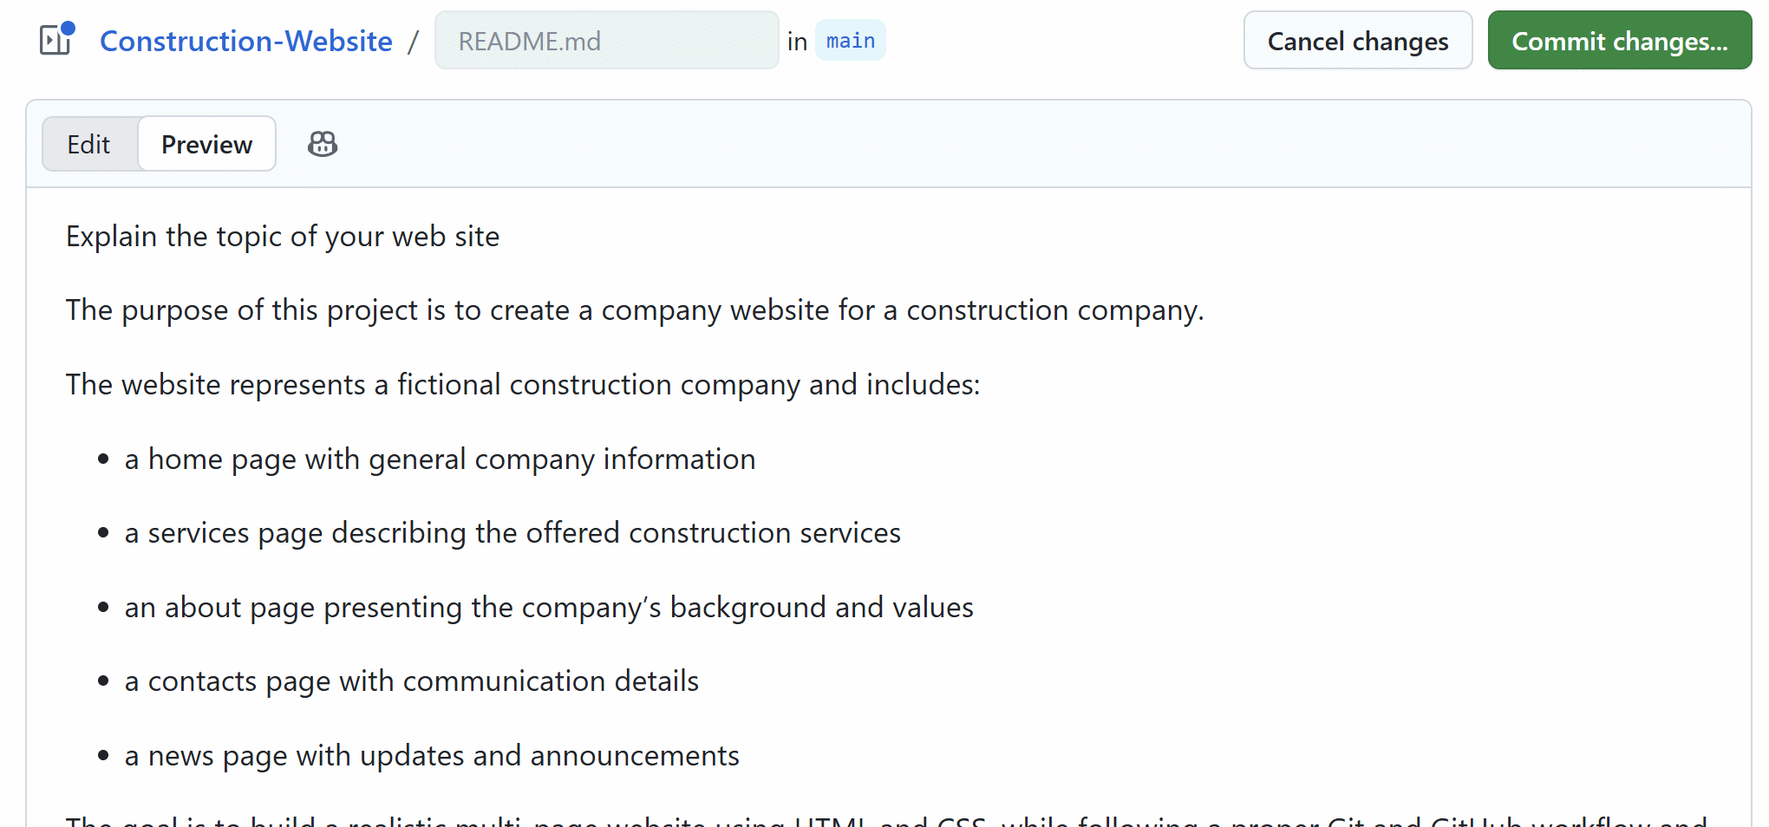
When you are ready, click [Commit changes…] and this step is completed. You can use this description as a part of your prompts or a plan for further action.

Services Page
The next page to be created is the "Services" page (services.html).
Write a prompt in the Copilot chat:
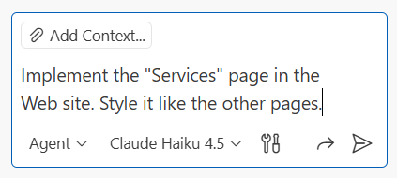
When you are ready, go to the Source Control section -> [Stage the changes for commit] -> Write a Commit Message (this is how to keep track of the changes made to the repository) and click Commit and Sync Changes to finally Push.
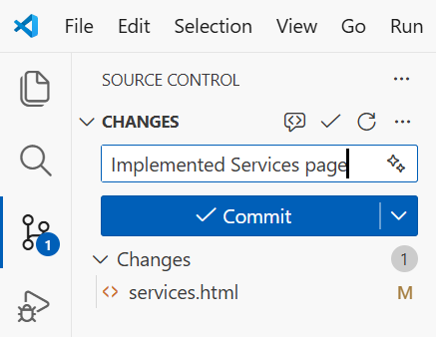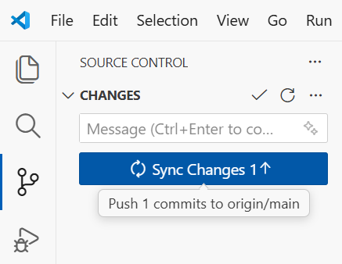
This is a sample of how your Services page may look like:


About Page
Create the "About" page (about.html), then Commit & Push.
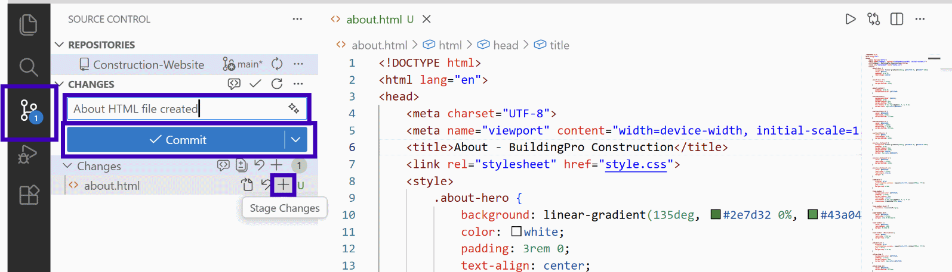

Contacts Page
Create the "Contacts" page the same way as you did with the previous ones. Then, commit and push the changes.
Next, ensure that about.html is correctly linked from the navigation menu. If not, ask Copilot to fix it. Ask for corrections until the website looks as expected.
When you are ready, Commit and Push. Do the same for the other sections from the header.

Publish to Netlify
Your next task is to publish your Web site live on the Internet.
To make a website publicly accessible, it must be hosted in a hosting platform. In this course we suggest that you use Netlify for this purpose: https://www.netlify.com. Alternatives are Vercel and Render.

Register in Netlify
The first step is to register on the Netlify platform, it’s free.
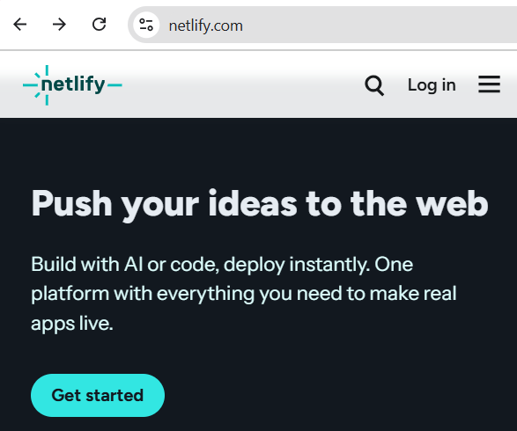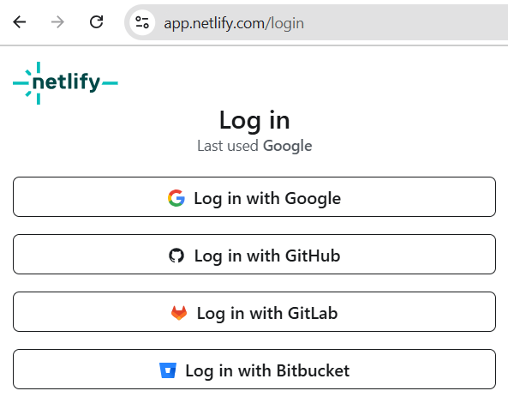

Deploy from GitHub
When you are done with this, it’s time to deploy the website. For this exercise, the website will be deployed using Netlify by connecting it to the GitHub repository.
- Open Netlify and select [Import from Git].
- Authorize GitHub connection with your profile for Netlify.
- Choose your repository for deployment.
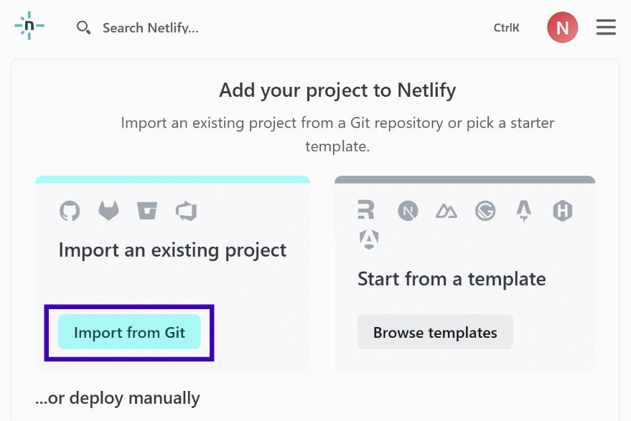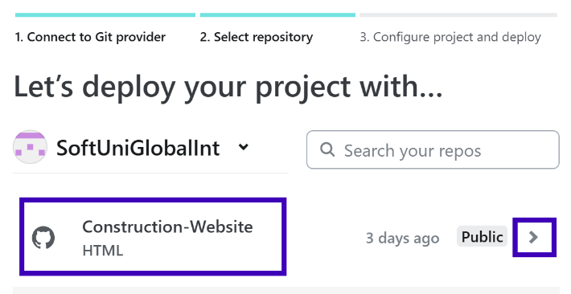
Enter a subdomain name for your site, e.g. "my-project" will be deployed to https://my-project.netlify.app.
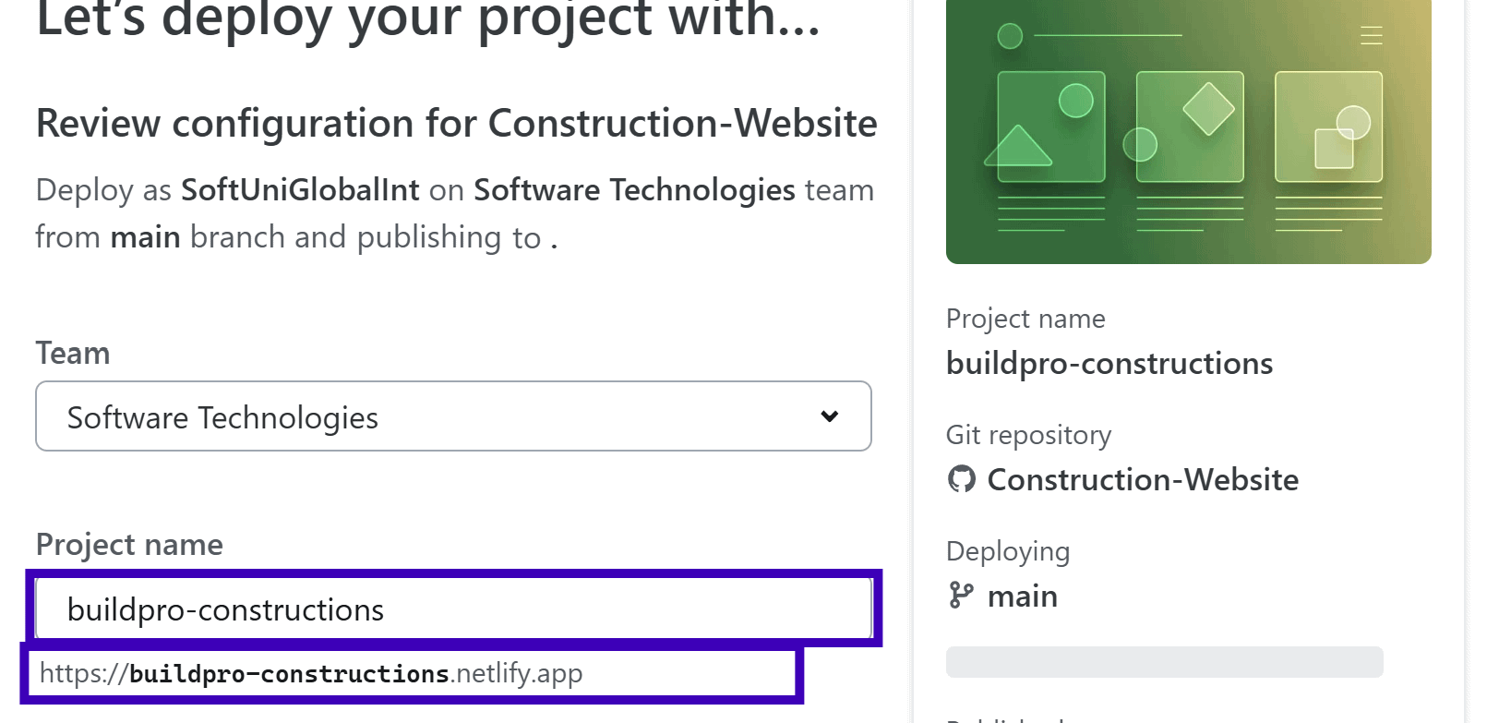
Select deployment branch (use the default "main"):
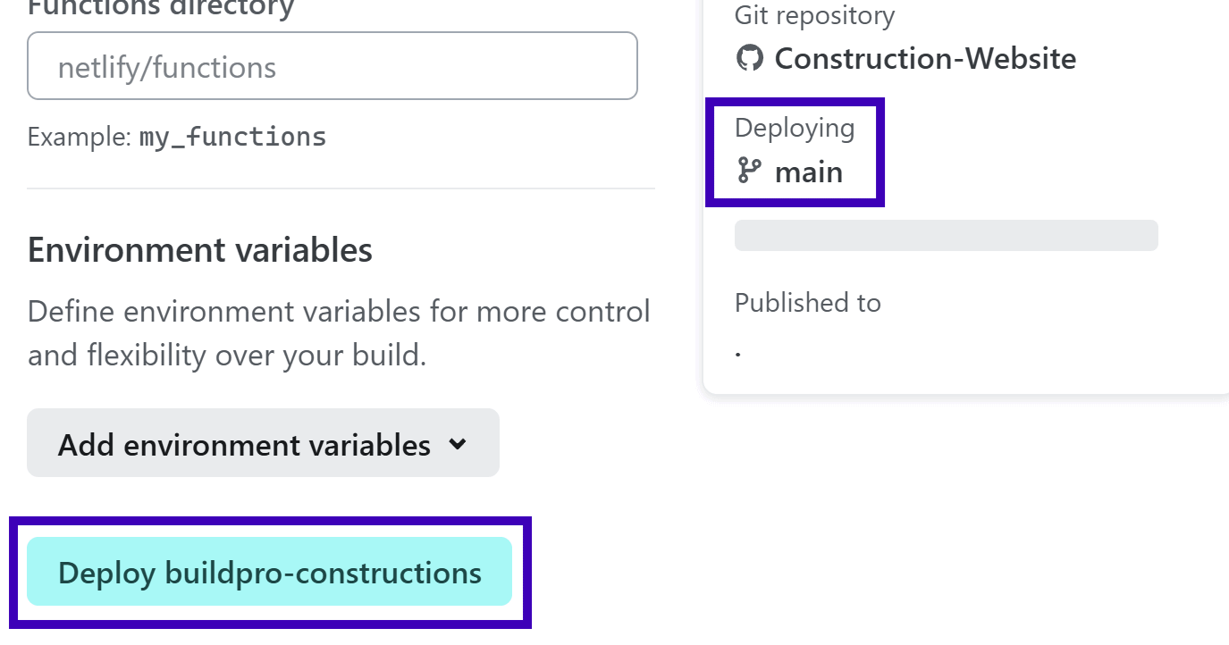
This is the link for your website, and you will be able to see it when you click the green link. You can change the link from Quick setup:
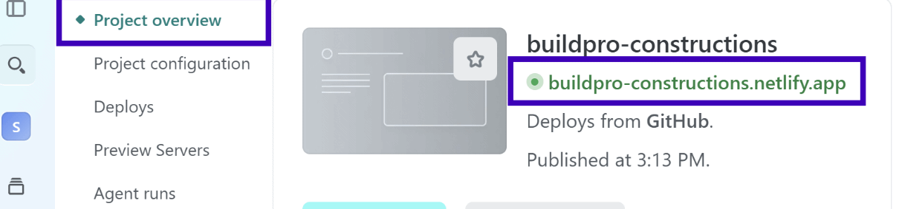

Continuous Deployment
Once deployed, it is important for the website to stay up to date automatically. Netlify supports the feature Continuous Deployment. This means that whatever changes have been pushed to the main branch on GitHub, will be published directly on your website.
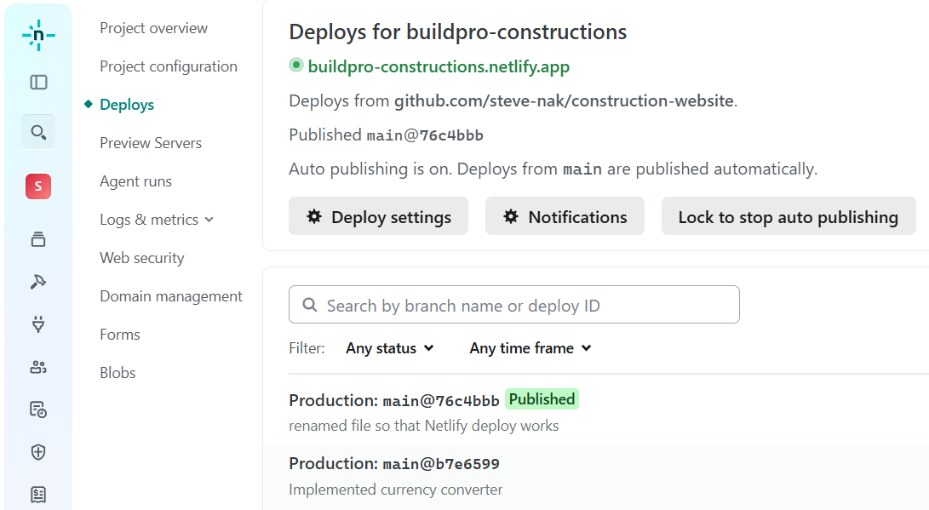
The above screenshot shows that "Auto Deploy" is enabled for your project in Netlify. This will auto-deploy the project from GitHub on push in the "main" branch. Continuous deployment is enabled by default in Netlify.
To test this functionality, create a new page "News", Commit and Push it and open the website from the link on Netlify again. You should be able to see the new page live on the Internet without any additional steps.
Now you can auto-deployment practice more, e.g. by making the site logo and title clickable (in the navigation bar). When you are ready locally on Visual Studio Code, Commit and Push the changes to GitHub. Open the website from the link to see if the changes have been automatically deployed.

Stop Auto-Deployment
Continuous deployment (auto-deploy on push in GitHub) costs Netlify credits. If you don't need it, you can stop it and save deployment credits on your free or paid plan. Many developers prefer manual deployment, for more flexibility and for reduced costs. You can disable auto-deploy by clicking the [Lock to stop auto publishing] button:
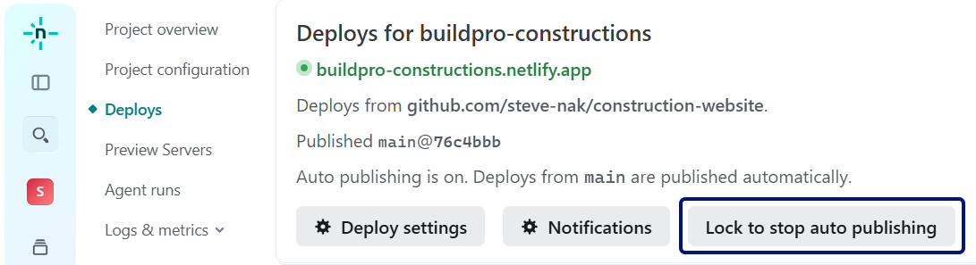

Using Branches
This task focuses on practicing and understanding how Git branches work. Start from the project created in the previous exercise.

Create a New Branch
Create a branch called "v2" through Visual Studio Code. As you are using a project with some commits made already, it is important to create your branch from the last commit you have made. Otherwise, the last changes you have made won’t be visible in the new branch:
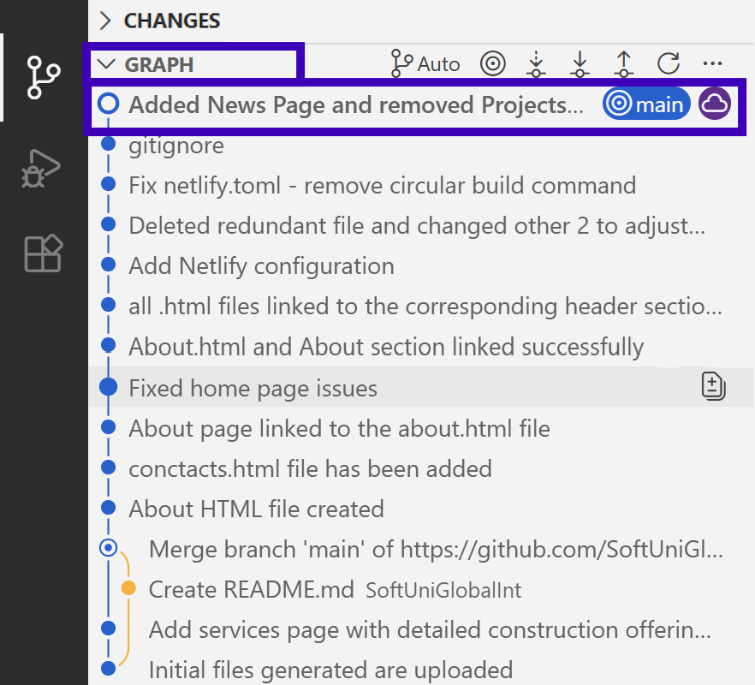
Follow these steps:
VS Code -> Source Control -> Graph -> Click Main
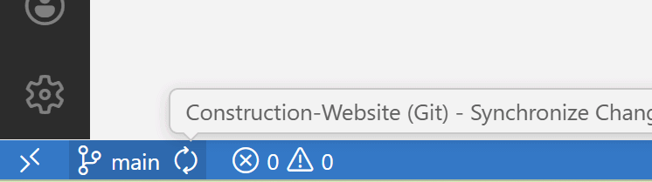
Options will appear under the Search bar. Select "Create new branch" and select a suitable name.
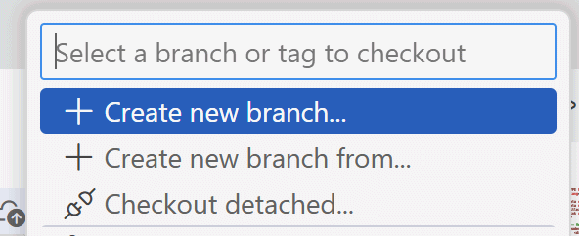
Publish the new branch:
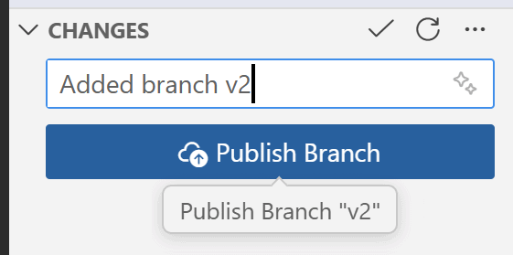

Make Changes, Commit and Push
Instruct the AI to restructure the Web site or make a visible change -> Commit and Push.
The branch you are committing to is shown next to the name of the repository. You can change it by clicking and selecting another branch. However, for this example, commit to the new branch you have created.
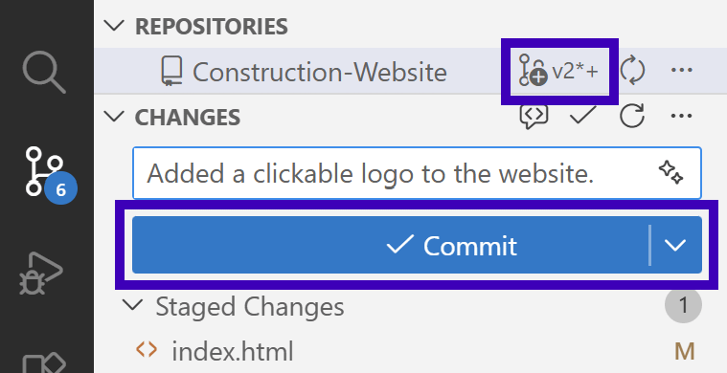
Then click [Sync Changes].
At this point, your changes are committed and pushed to the "v2" branch.
Important: these changes will not be deployed to the live website because Netlify is connected to the main branch.

Implement More Changes
Implement more changes in the branch "v2".
- Merge all pages into a single HTML page with tabs
- With files inside: index.html, styles.css, scripts.js (if a JavaScript file is needed)
Fix bugs and/or polish your work.
Finally, commit and push in the v2 branch.
At this point, the repository contains two branches:
- main → stable version (multi-page website, live, already launched officially on Netlify by you)
- v2 → new version (newer version of the website with the changes you just made)

Pull Request
Merge branch "v2" to "main"
Open your repo online in GitHub.com. Go to [Pull requests] and select "New pull request":
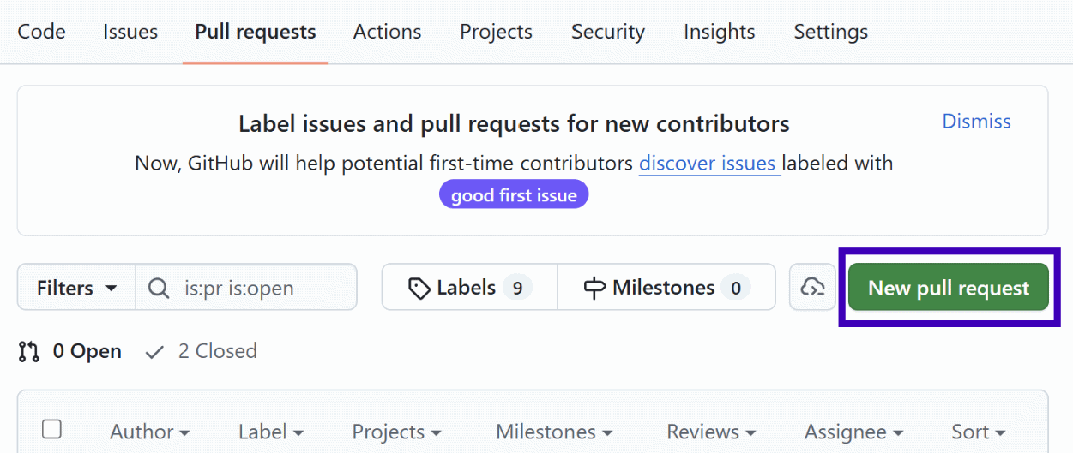
Now you need to set the "base:" to be the main and the "compare:" to be the newly created branch. This way GitHub compares the old main branch to the one with the new updates you just made.
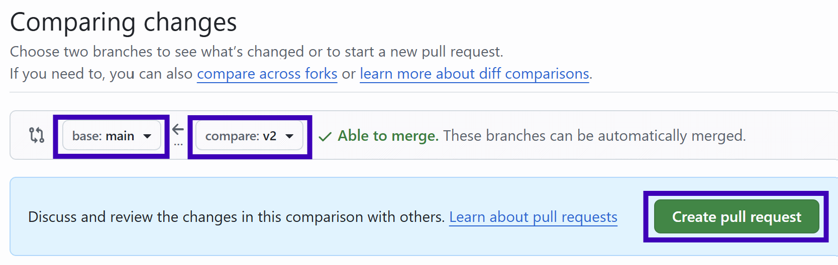
Before you create a pull request, you can check what changes have been made and compare the two codebases. Simply scroll down until you see some fields looking like this:
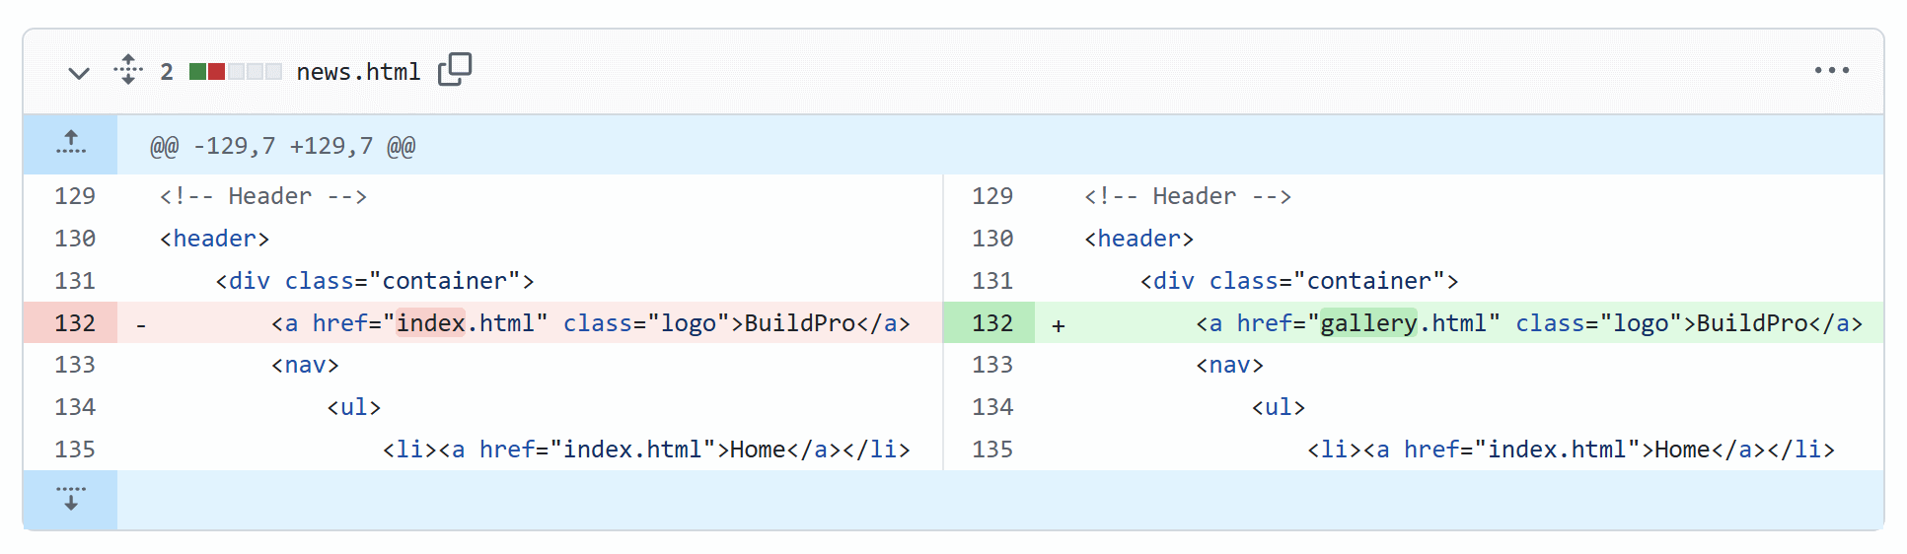
When you have done your review of the changes, you can create a pull request and fill out the form provided. Add a suitable title and description which will provide all the necessary information about the changes that are being made. Usually, it is longer than this:
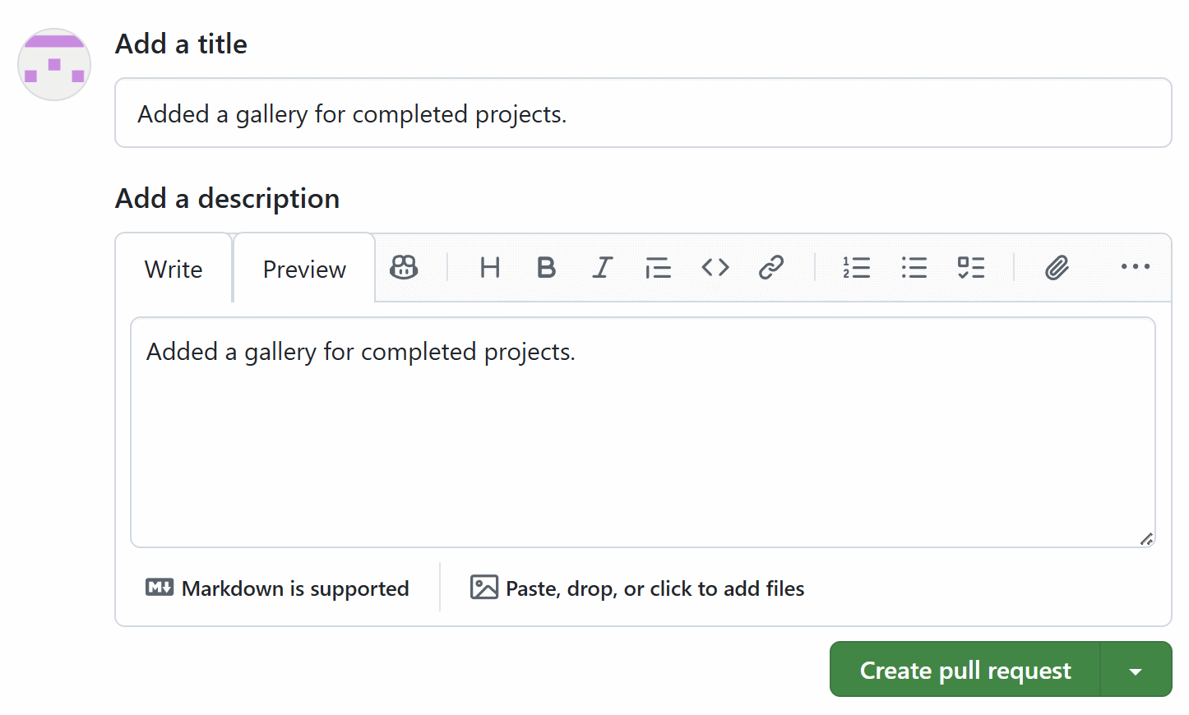
Create the pull request. You can find your new request in the Pull Requests section:
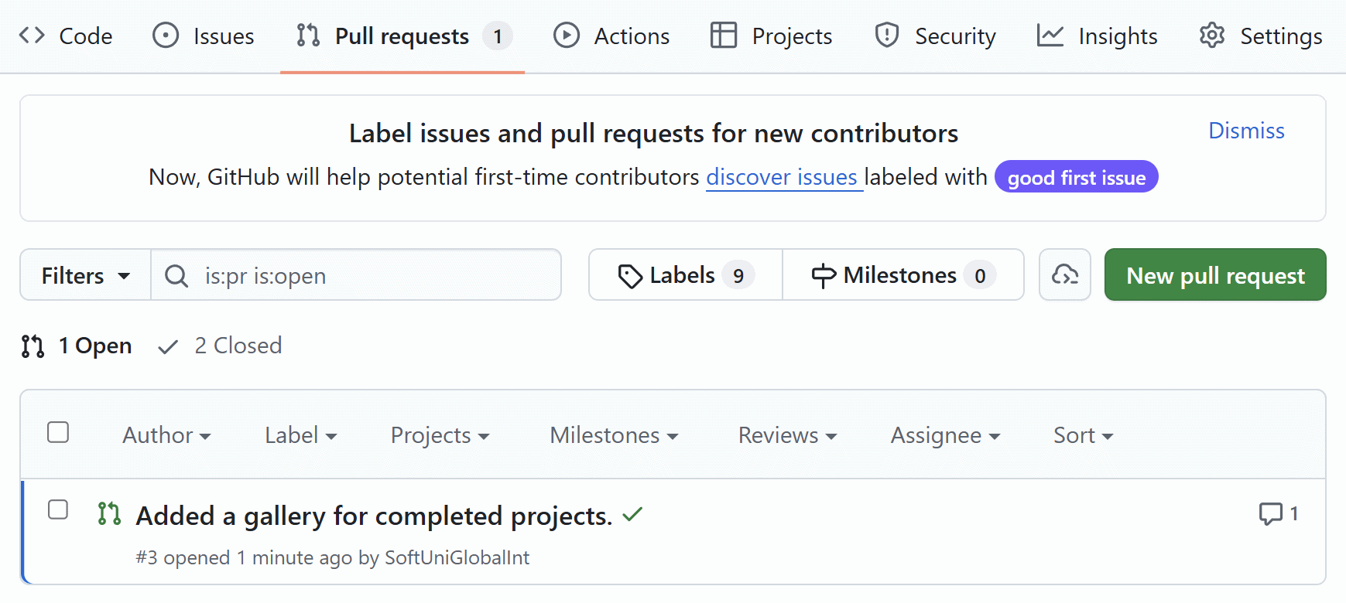
Click the request and scroll down for more details. This shows that Netlify doesn’t see an issue and a deploy can be done successfully:
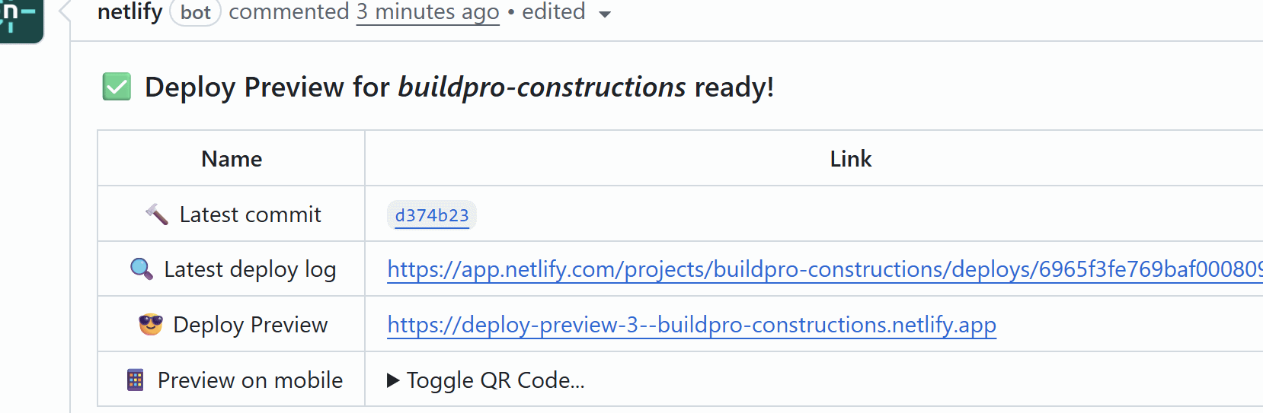
Click "Merge pull request" -> Confirm merge. Merging a pull request copies all changes from branch v2 to the main branch. This can be done in case of no conflicting changes in the same file. Otherwise a manual merge of conflicting code will be required.
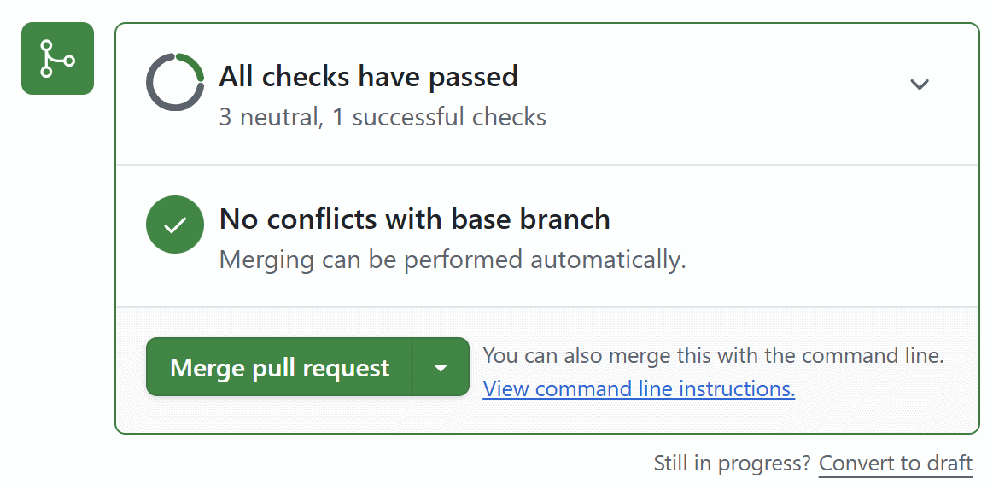
Now the changes have been added to the main branch and when you open the website link from Netlify, you can see the changes have been auto-deployed.

Delete the Old Branch
Delete the old branch "v2" and switch back to "main". You don't need the old branch "v2" anymore.
Open the repository online at GitHub.com and click "Branches", then select the trash bin icon next to the one you want to delete:
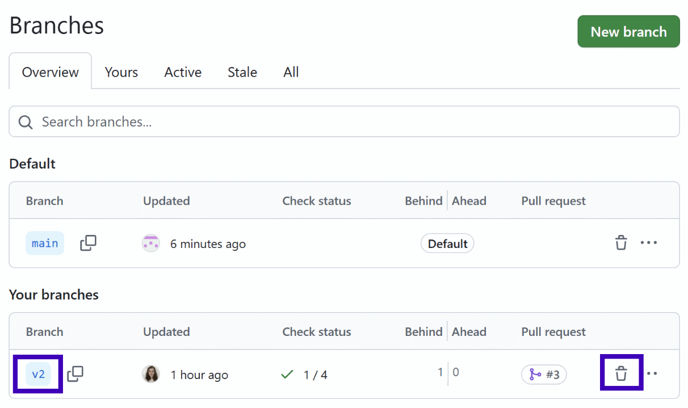
Open Visual Studio Code and switch from branch "v2" to the main branch again by clicking here:
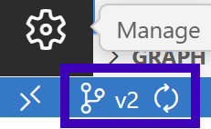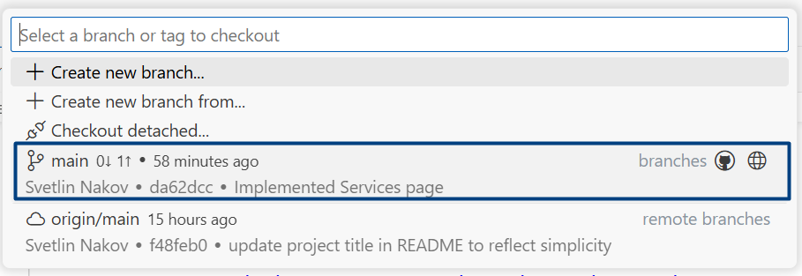
Sync the changes. This way you will copy locally what you did on the browser.

Unit Converter App
Develop a "Unit Converter" app, step by step, using a GitHub repository.

App Structure
First, define the basic app structure (simple HTML + CSS):
- Simple structure: unit-converter.html, unit-converter.css, unit-converter.js
- Include header, footer, navigation
Commit & Push your work.

Publish to GitHub
Publish your code to a new GitHub repository created for this specific project.

Implement Metric Converter
- Implement metric converter: mm, cm, m, inch, foot, mile, etc.
- Commit & Push

Implement Temperature Converter
- Implement temperature converter: Celsius, Fahrenheit, etc.
- Commit & Push

Implement Currency Converter
Try to implement currency converter: USD, EUR, GBP. Retrieve the rates in real-time, from relevant API.
- This feature is more complicated. It may be successful or may fail.
In some cases, planned features may not work as expected or may require resources that are not currently available. In such cases, continue working on the code before implementing these features. Discarding these changes may be necessary.
In the case of currency conversion, there are some possible setbacks that could make the feature unusable:
- Exchange rates are not fixed
- Real currency conversion requires an API
- Hardcoded values do not provide accurate results for real-world applications

Discard Changes
Assume that you don't like the implemented currency converter. You want to cancel pending changes and continue working from the previous stable state of the app.
You can discard the changes from Source Control on Visual Studio Code:
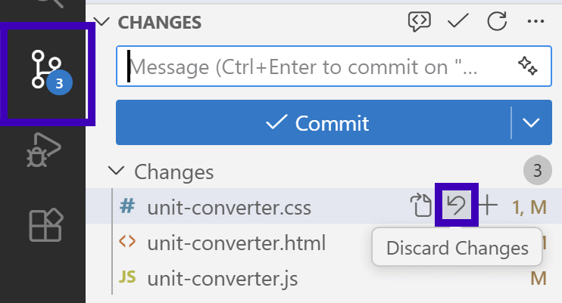
! This step works for uncommitted changes only.

Implement More Functionality
Implement more converters to practice and prepare for the next steps. Commit and push after every successfully implemented and tested converter. Here are some converter ideas:
- Weight converter: mg, g, kg, ton, ounce, pound, etc.
- Volume converter: ml, liter, gallons, etc.
- Speed converter
- Area converter
- Pressure converter
In this case the "Discard Changes" functionality cannot be used – all changes have been pushed to the repository in the main branch. You can find the correct version, download it as ZIP file and replace your project with the ZIP contents to get back to an older version from the Git history.

Removing Old Commit
Sometimes successful commits must be removed as plans and websites change and evolve constantly. Let’s safely remove the speed converter feature (or any other converter you have chosen to implement).
One way of doing this is by following these steps with the knowledge you got in the previous exercise:
- Create a new branch from the last commit you have made and name it properly (e.g. "speed converter deletion").
- Undo the changes in the new branch – use GitHub Copilot and explain to "remove the speed converted -> UI and underlaying logic".
- Commit this update to the new branch.
- Merge with the main branch like we did in the previous exercise.
- Delete the branch, created for the deletion of the speed converter.
- Go back to the main branch on Visual Studio Code.
- Sync changes via Visual Studio Code.

Local File Timeline
In some cases, you will want to bring back a feature you have deleted in the current version of the project but exists as a separate commit in the past. Let’s implement the speed converter again (the same one you reverted in the previous step):
Create a new branch from the last commit you have made and name it properly (e.g. "restore-speed-converter")
Go to the files in File Explorer:
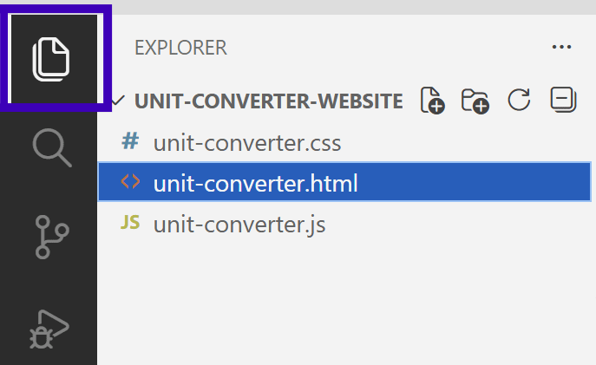
Every file has a Timeline in which all changes made to it can be traced. Find the version of it where the speed converter still existed:
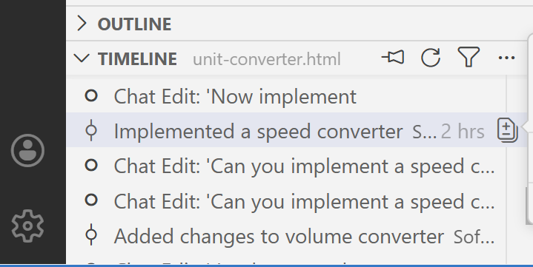
Click it and you will see two parallel tabs where there will be marked all changes between the current version of the file and the old version you are reviewing (the one with the speed converter applied):
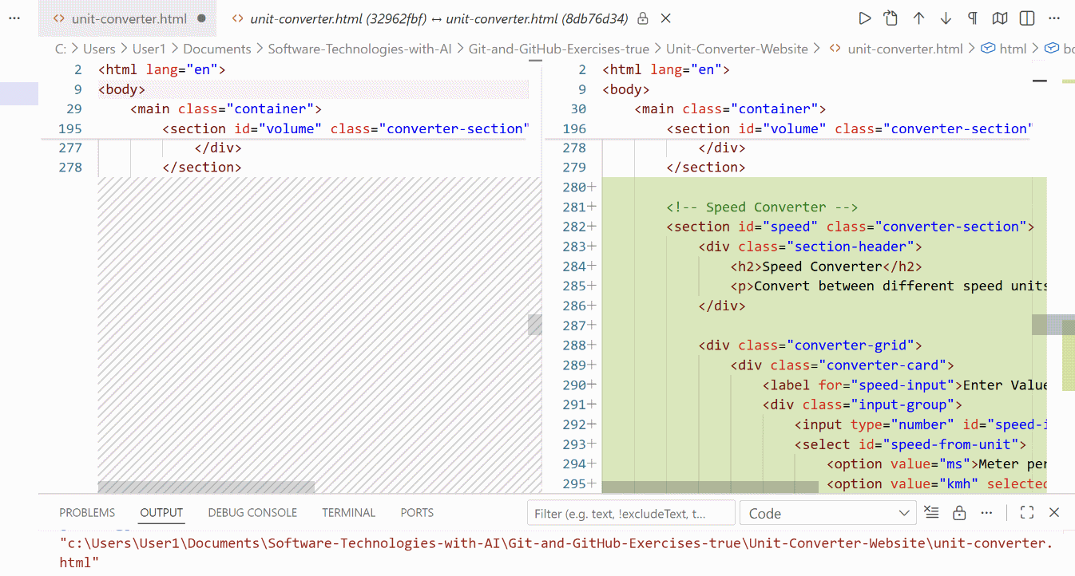
Copy the code from the green segments and paste them in the current version of the file (you need to click the unit-converter.html separately, as the comparison mode is view-only). Alternatively, you can find the old, deleted code in the GitHub commit history in your project repo.
Commit the changes and merge the branch following the same process as in the previous tasks.

